 | BAHRIA UNIVERSITY, (Karachi Campus)  Department of Software Engineering  Assignment 3 - Fall 2022

COURSE TITLE: Calculus and Analytical Geometry COURSE CODE: GSC-110
Class: BSE-I (B) Shift: Morning
Course Instructor: Mr. Daniyal ur Rehman Time Allowed: 1 Week
Submission Date: 11-1-2023 Max. Marks: 5 Marks

Question No. 1 [CLO1/3: 5 Marks]
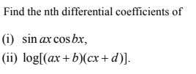

Question No. 2
Apply Leibnitz rule of differentiation to find the following
Question No. 3
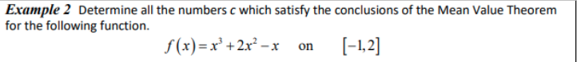
Question No. 